# Set up Azure API Management

1. Create a new API Gateway in Azure – search API Management 🡪 Create

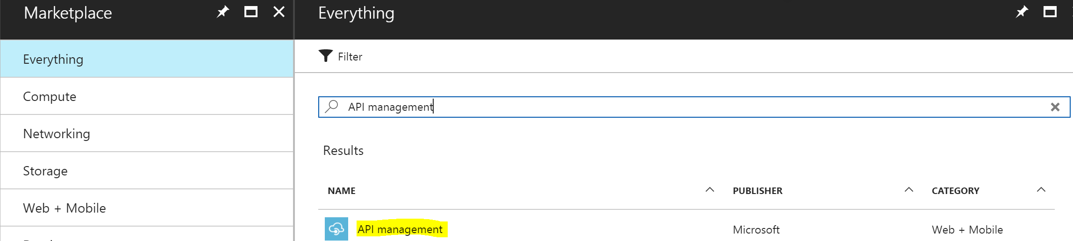

1. Configure the values for API Management – example below

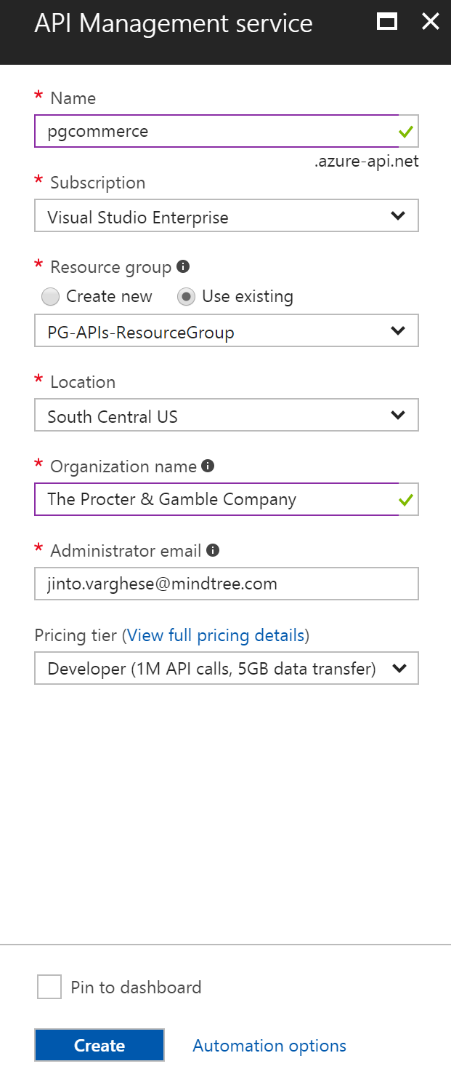

1. Creating the API Management service could take about 15 minutes or so.

# ConfigurE API Management

1. Go to Publisher Portal of the API Management

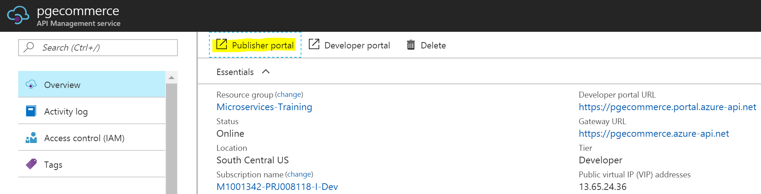

1. Delete the test Echo API

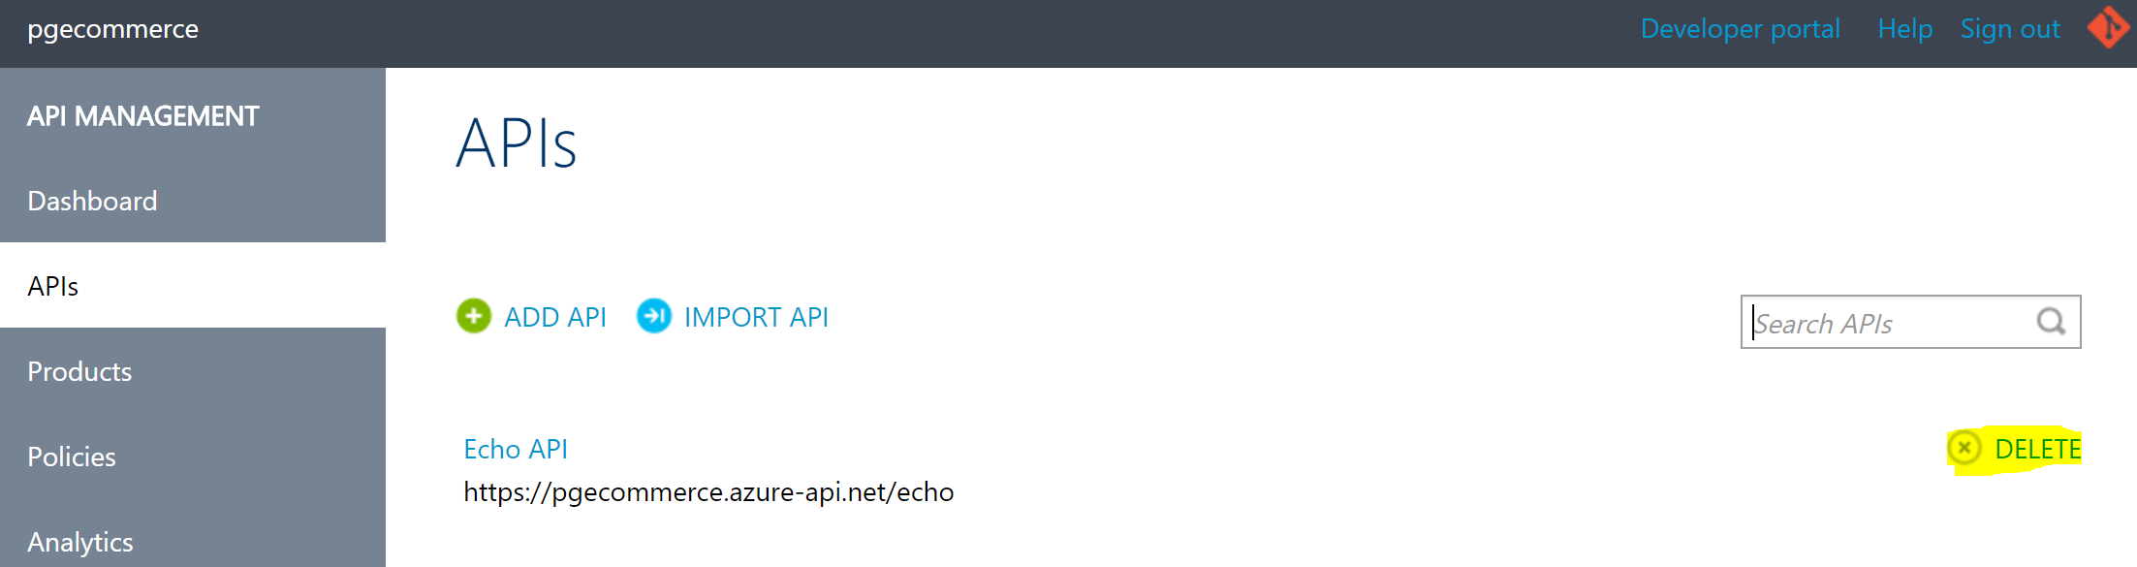

1. Delete the existing Products – Starter and Unlimited

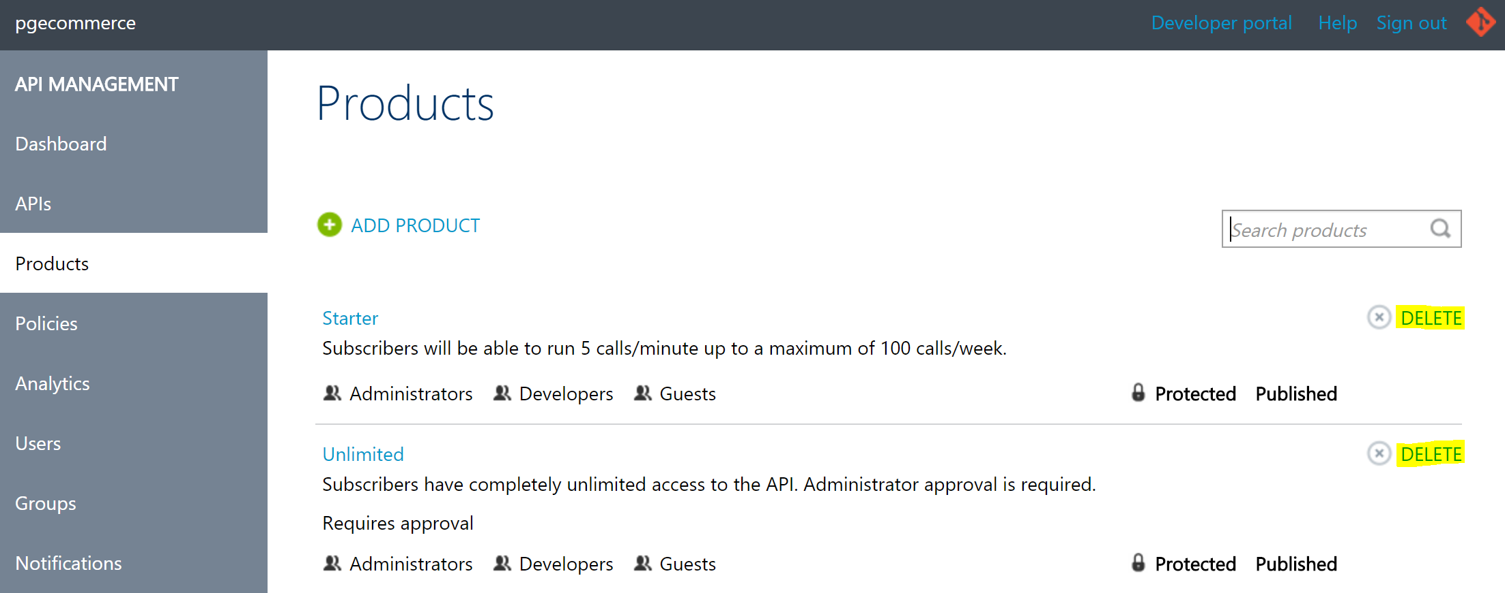

1. Create a new product called “Free Trial” using “Add Product” option. This is the product to which all APIs will be configured initially in the training.

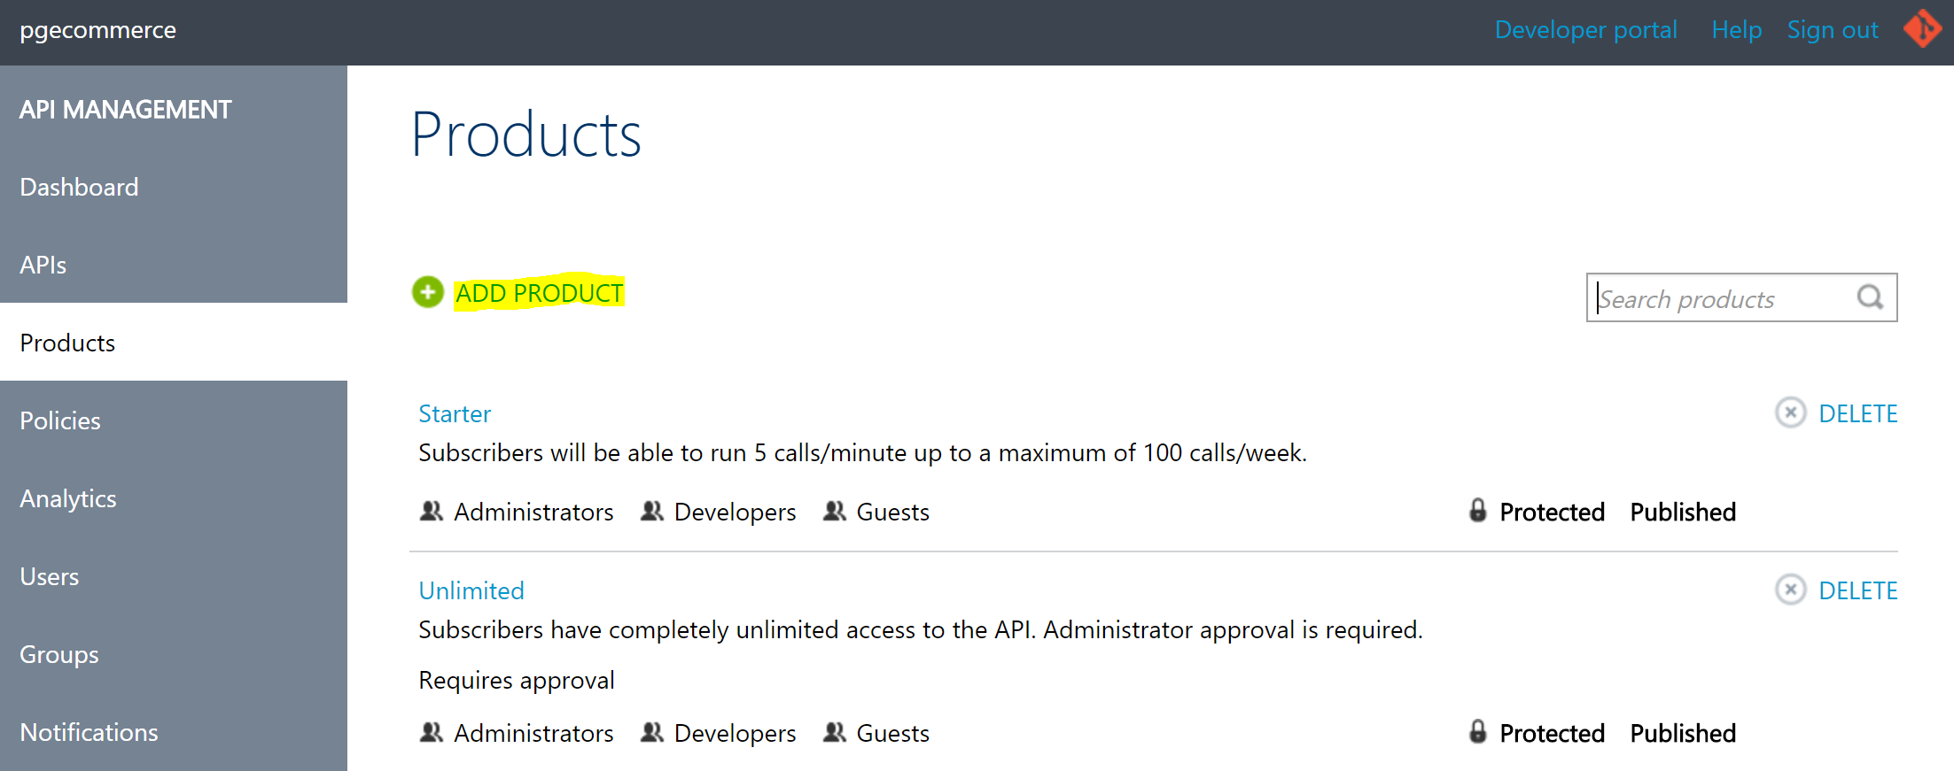

1. Configure the values as shown below. Ensure to uncheck “Require Subscription” box.

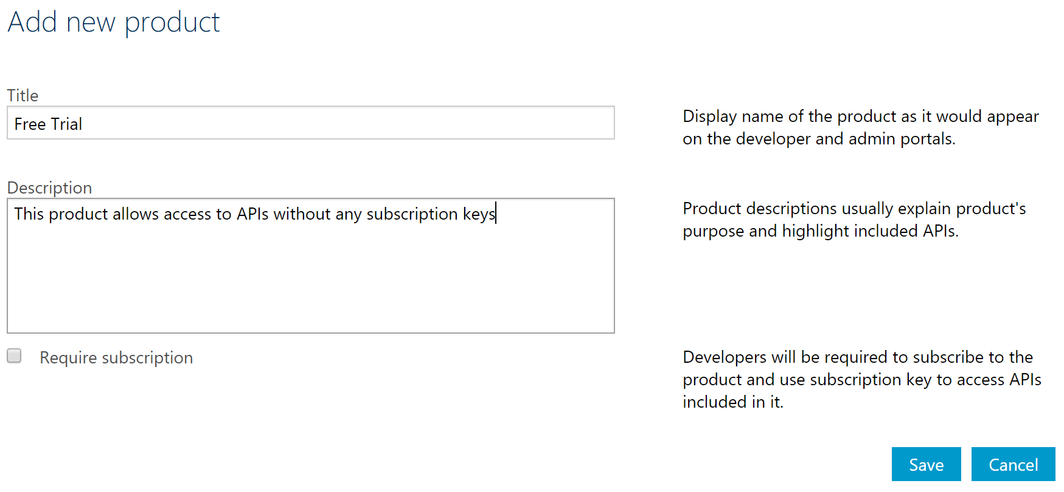

1. Publish the newly created product as shown below.

*Note: it may not allow publishing if there is no API associated to the product. In such a case, do this step after an API is created in API Management and associated with this product.*

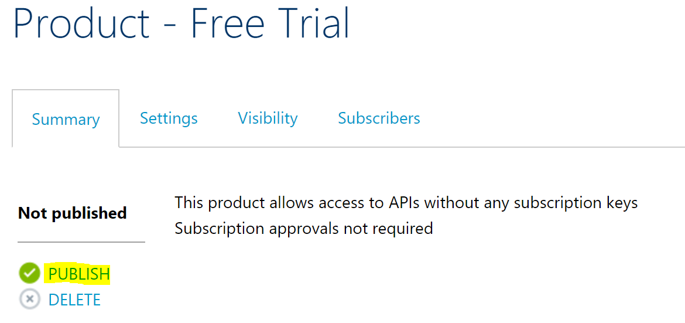

# References